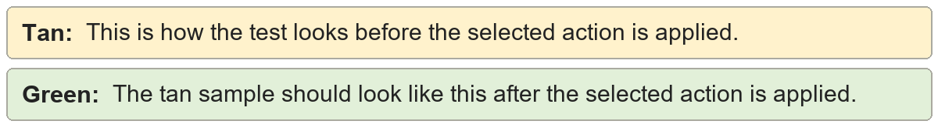
Empty table rows | Shared table sample.
Cell 1.1 | Cell 1.2
Cell 2.1 | Cell 2.2
Empty table rows | Shared table sample.
Cell 1.1 | Cell 1.2
Cell 2.1 | Cell 2.2

Empty table columns | Shared table sample.
Cell 1.1 | Cell 1.2
Cell 2.1 | Cell 2.2
Cell 3.1 | Cell 3.2
Empty table columns | Shared table sample.
Cell 1.1 | Cell 1.2
Cell 2.1 | Cell 2.2
Cell 3.1 | Cell 3.2

Cell padding | Shared table sample.
Cell 1.1 | Cell 1.2
Cell 2.1 | Cell 2.2
Cell 3.1 | Cell 3.2
Cell padding | Shared table sample.
Cell 1.1 | Cell 1.2
Cell 2.1 | Cell 2.2
Cell 3.1 | Cell 3.2

Direct cell formatting | Shared table sample.
Cell 1.1 | Cell 1.2
Cell 2.1 | Cell 2.2
Cell 3.1 | Cell 3.2
Direct cell formatting | Shared table sample.
Cell 1.1 | Cell 1.2
Cell 2.1 | Cell 2.2
Cell 3.1 | Cell 3.2

Border normalization | Shared table sample.
Cell 1.1 | Cell 1.2
Cell 2.1 | Cell 2.2
Cell 3.1 | Cell 3.2
Border normalization | Shared table sample.
Cell 1.1 | Cell 1.2
Cell 2.1 | Cell 2.2
Cell 3.1 | Cell 3.2

Border removal | Shared table sample.
Cell 1.1 | Cell 1.2
Cell 2.1 | Cell 2.2
Cell 3.1 | Cell 3.2
Border removal | Shared table sample.
Cell 1.1 | Cell 1.2
Cell 2.1 | Cell 2.2
Cell 3.1 | Cell 3.2

Single-column table to text | Shared table sample.
Alpha
Beta
Single-column table to text | Shared table sample.
Alpha
Beta

